# OOP lab 3 outputs

Name: Saahil Ghulam Mohammad

Section: BCS-1D

Roll Number: 24K-0570

Q2: 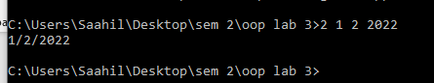

Q3: 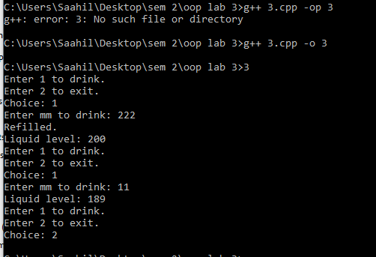

Q4: 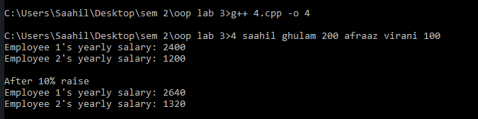

Q6: